

**Requirements Engineering Project 2024**

**System Requirements Specification (SRS) Document**

**Problem 4**



**SDH2B Group 5**

**Ice Ybanez, Matas Orliukas, Svitozar Menshchykov**

**Submission Date:**

**Table of Contents**

Problem Statement 2

SMART Project Goals 3

List of User Roles 4

Vision Statement 4

Actor's Grid 4

Use Case Grid 5

Glossary Grid 6

Use Case Diagram 7

Use Case Scenario Specifications 8

Non-Functional Requirements Grid 16

Business Rules Grid 17

User Story Map 18

Story Details 18

Card 18

Conversation 18

Confirmation Criteria 19

Appendix 21

Interview Questions 21

Interview Transcript 21

Trello Board Screenshots 23

Background Research 23

Bibliography 23

Project Retrospective 24

# Problem Statement

A multi-campus technological university, MTU has a student body of over 18,000 students and around 2,000 staff statewide. Due to the ever-increasing cost of living, students throughout MTU struggle to manage their finances during their studies.

At present, students have found a way of making money by selling their belongings to their peers. This is done by in-person exchange where the seller hands their unwanted item(s) to the buyer, and the buyer either pays with cash or Revolut, an online finance application. The seller then proceeds to either keep the cash in their pockets or use it right away. If the exchange is dealt through Revolut, it is more likely that the buyer would save their money as they don’t have to “carry” it with them. The lack of a structured platform for buying and selling items within MTU students and staff throughout County Cork results in inefficiency, limited reach, and potential security issues.

Students currently use the power of word of mouth to get the news spreading that they are selling belongings. They also take to social media to let their followers know what is available, by posting stories of their items with prices labelled. However, these story posts only last 24 hours and when they’re gone, they’re gone. Physical notice boards are one of the only ways students are informed of fundraising events. Staff are notified through emails on fundraising events and are communicating with one another, on a separate platform, when selling their items.

The desire for a convenient way to buy and sell used and unwanted items is increasing day by day with more people needing extra space in their homes or needing extra cash for financial reasons. A shared application between students and staff could support the financial needs and charitable causes of both. This would thus create an opportunity for students to manage their finances through sales and give the staff a convenient way to fundraise. An MTU based marketplace application allows students to post their unwanted and/or unneeded items for sale, and for their peers to easily make quick purchases.

System Requirements include:

* Ability to create and modify item listings within user profile
* Budget management
* Filter marketplace listings to make it easier for users to find what they want
* Fundraising tracker

# SMART Project Goals

**S - Specific**

*What does the business want to achieve?*

The business wants to solve the problem of the financial struggles of MTU students by developing a platform where students can buy and sell items on a marketplace. The business also wants to develop a space for MTU staff to fundraise for a common cause.

*Where the process will be taking place?*

The process will be taking place online where sellers can upload their items for buyers to purchase.

*Why is the entity pursuing this goal?*

To address financial struggles, centralise fundraising opportunities and improve on the efficiency of selling and security of buying.

**M - Measurable**

*How much resources/time/etc.*

*How many team members/days/etc.*

*How will we know when it’s done?*

The sales department will improve company profits by 10% over a 6 month period by improving customer satisfaction.

**A - Achievable**

*Is this the reality of its niche (is it a fast-growing one, is there a demand for these products/services)?*

There is a demand for this service and the MTU community could greatly benefit from this.

**R - Relevant**

*Does this idea seem worthwhile?*

This idea seems worthwhile as seen through interviews that an improved system was needed.

**T - Time Bound**

*When is the deadline?*

*When is the first milestone, second, and so on?*

The deadline is around 3 months.

1 month brainstorming and gathering information from students and staff of the current system and how to make it better.

1 month developing the idea to cover necessary functionality.

1 month finalise features and supporting charities.

# List of User Roles

* Student
* Staff
* Seller
* Buyer
* Charity

# Vision Statement

***For*** MTU Student and Staff,

***Who*** have difficulty managing their finances and want to sell their items or fundraise for a charity by selling items,

***The*** MTU Marketplace,

***Is*** an online marketplace,

***That*** allows students and staff to easily list and sell items they no longer need, while also providing a platform for charity fundraising through the sale of goods,

***Unlike*** selling items through social media or by word of mouth,

***Our product*** is efficient, simple and that allows selling and buying making it easy to fundraise and raise money.

# Actor's Grid

| ID | Name | Description | Goals |
| --- | --- | --- | --- |
| AC01 | Student |  | Sell items, Purchase items for sale, Modify items, Set budget, Track spending and sales, View income and expenses |
| AC02 | Staff |  | Sell items, Purchase items, Choose charity, View fundraising progress |
| AC03 | Charity |  | Receive donations, View fundraising progress, Provide impact of donations |
| AC08 | Student Seller |  | Posting an item for sale, View active listings, Modify an existing listing, Remove a listing after sale, Log revenue and expenses to manage finances, View a summary of earnings, Set budget goals |
| AC09 | Staff Seller |  | Posting an item for sale, tagging it for charity, View active listings, Modify an existing listing, Remove a listing when the fundraising goal is met |
| AC10 | Charity Organiser |  | Set Charity Goals, Track total funds raised for their charity, Provide updates on fundraising goals |
| AC11 | Buyer |  | View available items, Filter items (search for a specific item, as well as select items sold for charity purposes), View details of an item, Contact the seller, Make a purchase |

# Use Case Grid

| ID | Name | Description |
| --- | --- | --- |
| UC15 | Remove a listing after sale |  |
| UC17 | View Financial Summary | Allows a student seller to view their financial summary in terms of their budgeting goal and how much money they have earned from selling. |
| UC16 | Track revenue |  |
| UC18 | Set budget goals |  |
| UC29 | Track expenses |  |
| UC26 | View item details |  |
| UC28 | Make a purchase | Allows a buyer to make a purchase of items on the marketplace. |
| UC27 | Contact the seller |  |
| UC24 | View available items | Allows a user to view listed items that are available which can be refined using filters. |
| UC20 | Remove a listing |  |
| UC10 | Receive donations |  |
| UC05 | Track spending and sales |  |
| UC02 | Purchase items |  |
| UC01 | Sell items |  |
| UC06 | View income and expenses |  |
| UC09 | View fundraising progress |  |
| UC08 | Choose charity |  |
| UC07 | Puchase items |  |
| UC11 | Provide impact of donations |  |
| UC03 | Modify items |  |
| UC04 | Set budget |  |
| UC22 | Track charity funds raised | Allows a Charity Organiser and Staff Seller to track the total funds raised for their charity through item sales. |
| UC21 | Set Charity Goal | Allows a user to set a number goal for their chosen charity. |
| UC23 | Update goals |  |
| UC19 | Post an item for sale | Allows a user to post an item they want to sell on the MTU Marketplace. |
| UC13 | View active listings |  |
| UC14 | Modify an existing listing |  |

# Glossary Grid

| Name | Aliases | Labels | Description |
| --- | --- | --- | --- |
| Fundraising | Collecting |  | The seeking of financial support for a charity or cause. |
| System Boundary | Limit |  | A way to divide items from another |
| Budgeting | Allocate |  | Allow or provide a particular amount of money in a budget. |
| Listing | Record |  | An entry in a list or register. |
| Item Category | Item Division |  | A way to group similar items together. |
| Use Case | Situation |  | A specific circumstance in which a product or service could potentially be used. |
| Transaction | Deal |  | An instance of buying or selling something. |

# Use Case Diagram

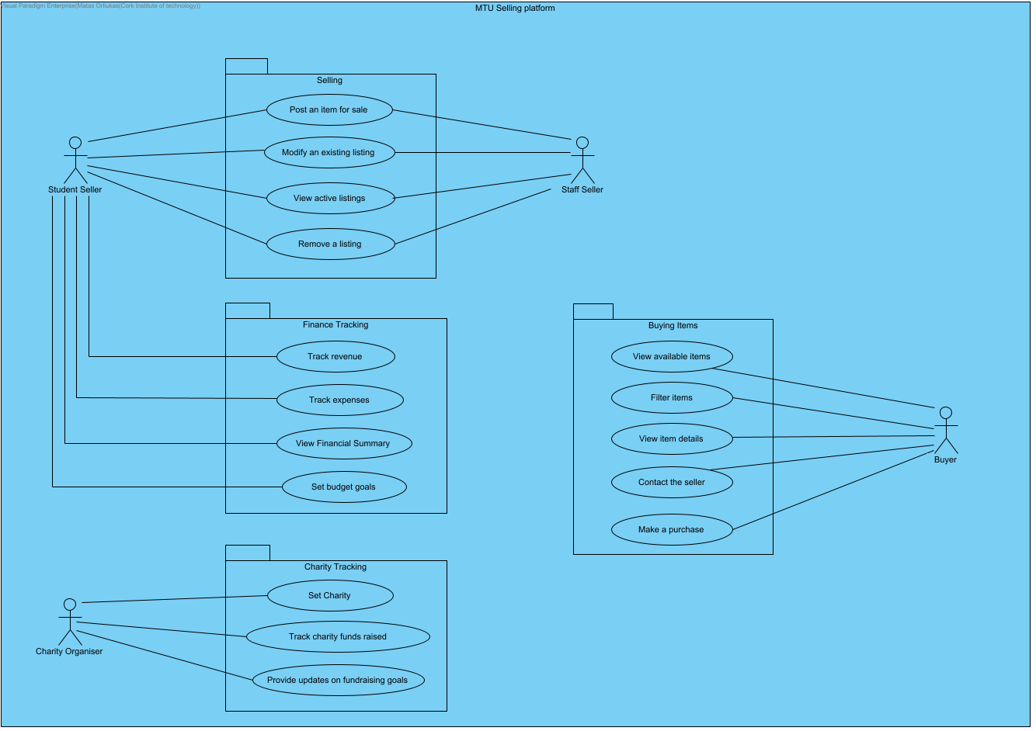

# Use Case Scenario Specifications

**Svitozar’s Use Cases:**

Post an Item for Sale, Track Charity Funds Raised

Use Case Name: Post an Item for Sale

Actors: Staff Seller (primary), Student Seller (primary)

Summary Description: Allows a user to post an item they want to sell on the MTU Marketplace.

Priority: High

Pre-Condition:

1. The user is registered and logged into the system.

2. The user has an item they wish to sell with relevant details (title, description, price, etc.).

Post-Condition(s):

• The item is successfully listed in the marketplace

• The user can view their item in their profile and the active listings.

Use Case Name: Track Charity Funds Raised

Actors: Charity Organiser (primary), Staff Seller (primary)

Summary Description: Allows a charity organiser and Staff Seller to track the total funds raised for their charity through item sales.

Priority: High

Pre-Condition:

1. The charity organiser is registered and logged into the system.

2. Fundraising activities have been recorded in the system.

Post-Condition(s):

• The fundraising summary is up-to-date.

• The system displays the fundraising summary and the organiser can view detailed fundraising progress.

**Matas’ Use Case Specification:**

Use case name:View available items

Actors:Students/Staff

Summary Description: Allows users to browse and view details of items listed for sale on the platform

Pre-Conditions:

The user must be logged into the system

The system must have active listings

Post-Conditions:

The user has browsed the available items.

|  |
| --- |
| 1. The user goes to the marketplace website. |
| 2. The user logs in using their credentials. |
| 2.a. The user doesn't have an account |
| 1. Click on register. |
| 2. Enter Student or Staff credentials. |
| 3. Click create account. |
| 3. The user navigates to the marketplace. |
| 4. SYSTEM Displays all available items. |
| 4.a. No active listings |
| 1. SYSTEM Checks again for available listings |
| 2. if no active listings |
| 2.1. SYSTEM Displays a message "No items for sale". |
| end if |
| 5. The user clicks on the filter option. |
| 6. The user applies their desired filters to the available items. |
| 7. SYSTEM Refines listings based on these filters. |
| 7.a. Filter returns no results |
| 1. SYSTEM Displays a message "No items match your criteria". |
| 2. The user can modify or reset filters. |
| 8. The users selects an item |
| 9. SYSTEM Displays the item. |
| 9.a. User selects an expired or removed item |
| 1. SYSTEM Displays a message "This item is no longer available". |
| 2. The marketplace refreshes removing the removed/inactive item.  Business Rules:  B007  B008  B009  Non Functional Requirements:  REQ002  REQ001  REQ004 |

Use case name: Set Charity Goal

Actors:Staff

Summary Description: Allows MTU Staff to select or update a charity to receive proceeds from their item sales.

Pre-Conditions:

The user must be logged into the system as a MTU Staff member

The system must have a list of approved charities.

Post-Conditions:

The selected charity is associated with all future sales listings by the staff member

|  |
| --- |
| 1. The user goes to the marketplace website. |
| 2. The user logs in using their credentials. |
| 2.a. The user is not registered |
| 1. Click on register. |
| 2. Enter Staff credentials. |
| 3. Click on register. |
| 3. The user navigates to their profile. |
| 4. SYSTEM Displays their profile. |
| 5. The user clicks on the fundraiser option. |
| 6. SYSTEM Displays the fundraiser page. |
| 7. The user enters a number goal in the money raised section. |
| 7.a. The user doesn't enter a number |
| 1. SYSTEM Displays a message "No amount chosen for amount goal" |
| 2. The user enters a number. |
| 8. The user clicks save changes. |
| 8.a. The user doesn't have a chosen charity |
| 1. SYSTEM Displays a message "No charity chosen" |
| 2. The user clicks on change chosen charity. |
| 3. The user clicks on available charities. |
| 4. The user clicks save changes. |
| 9. SYSTEM Displays a message "Changes have been saved".  Business Rules:  B010  B011  B012  Non Functional Requirements:  REQ002  REQ004 |

**Ice’s Use-Case Specifications**

**Use case name:** Make a Purchase

**Actors:** Buyer

**Summary Description:** Allows a buyer to make a purchase of items on the marketplace.

**Pre-Conditions:**

The buyer has a registered account.

The buyer has a card to use for payment.

**Post-Conditions:**

The system displays confirmation of payment.

The seller receives a notification that a buyer has purchased their item(s).

**Scenario:**

|  |
| --- |
| 1. Buyer logs into their MTU Marketplace account. |
| 2. SYSTEM Display Log In page |
| 3. Buyer navigates the main Marketplace where items are displayed. |
| 4. Buyer clicks on item(s) they wish to add to cart. |
| 5. SYSTEM Cart update. |
| 6. Buyer navigates to cart page to make a purchase. |
| 7. SYSTEM Display cart page. |
| 8. Buyer clicks Complete Purchase to navigate to Payment page. |
| 9. SYSTEM Display Payment page with forms. |
| 10. Buyer enters payment details and completes purchase. |
| 11. SYSTEM Display confirmation of payment. |
| Extension: |
| 1.a. Buyer is not registered |
| 1. Buyer clicks REGISTER |
| 2. Buyer enters details |
| 3. Buyer completes registration by clicking on Register |
| 6.a. Buyer has no items in the cart |
| 1. System displays "No item(s) in cart" |
| 2. Buyer must navigate marketplace and add an item to cart to update cart. |
| 10.a. Buyer's payment details are incorrect |
| 1. System displays "Incorrect input details. Please try again." |
| 2. Buyer inputs correct details. |
| 3. Buyer completes purchase with correct payment details. |

**Business Rules:**

B004

B005

B006

**Non-Functional Requirements:**

REQ001

REQ002

REQ004

**Use case name:** View Financial Summary

**Actors:** Student Seller

**Summary Description:** Allows a student seller to view their financial summary in terms of their budgeting goal and how much money they have earned from selling.

**Pre-Conditions:**

Student seller must already have an MTU Marketplace account.

Student seller must have set up budgeting goal to view its progression.

**Post-Conditions:**

Student seller can view their budgeting goal progression.

Student seller can view how much they earned from selling.

**Scenario:**

|  |
| --- |
| 1. Student seller logs in to their MTU marketplace account. |
| 2. SYSTEM Display Log in page. |
| 3. Student seller navigates to their profile. |
| 4. SYSTEM Display profile page. |
| 5. Student seller navigates to the budgeting page. |
| 6. SYSTEM Display budgeting page. |
| 7. Student seller can see their financial summary. |
| Extension: |
| 1.a. Student seller is not registered |
| 1. Student seller clicks REGISTER |
| 2. Student seller enters details |
| 3. Student seller completes registration by clicking on Register |
| #.a. Student seller has no budgeting goal |
| 1. System displays only money earned from selling. |
| 2. Student seller has ability to set a budgeting goal |

**Business Rules:**

BR001

BR002

BR003

**Non-Functional Requirements:**

REQ001

REQ002

REQ004

# Non-Functional Requirements Grid

| ID | Kind | Name | Description |
| --- | --- | --- | --- |
| REQ001 | Performance | Page Load Time | The system must load pages within 3 seconds for up to 200 concurrent users. |
| REQ002 | Security | Data Encryption | User authentication must be implemented with multi-factor authentication (MFA). |
| REQ003 | Usability | Multi-Device Support | The system must be easy to use on mobile, tablet, and desktop devices. |
| REQ004 | Scalability | Future Growth Support | The system must handle increased user load without major architectural changes. |

# Business Rules Grid

| ID | Name | Rule |
| --- | --- | --- |
| BR001 | Rule1 | Users must log in to view their financial summary |
| BR002 | Rule2 | Students can only view financial summaries of their own accounts |
| BR003 | Rule3 | Users cannot alter historical transactions records shown in financial summaries |
| BR004 | Rule4 | Only registered users can make purchases |
| BR005 | Rule5 | Buyers must have a method of payment if they want to purchase items |
| BR006 | Rule6 | Buyers must provide delivery details |
| BR007 | Rule7 | System will categorize items |
| BR008 | Rule8 | Only active listings will be shown |
| BR009 | Rule9 | Users may filter items by category |
| BR010 | Rule10 | Only MTU Staff may set a charity |
| BR011 | Rule11 | Staff must select an approved charity |
| BR012 | Rule12 | Proceeds raised will be used for associated charity of staff |
| BR013 | Rule13 | Only registered users (Student Sellers and Staff Sellers) can post items for sale. |
| BR014 | Rule14 | Items for sale must be under approved categories |
| BR015 | Rule15 | Items for sale must have accurate information |
| BR016 | Rule16 | Only Staff members contribute to charity funds |
| BR017 | Rule17 | Each sale is linked to the chosen charity of the staff at time of listing |
| BR018 | Rule18 | The staff is notified when the fundraising goal is reached |

# User Story Map

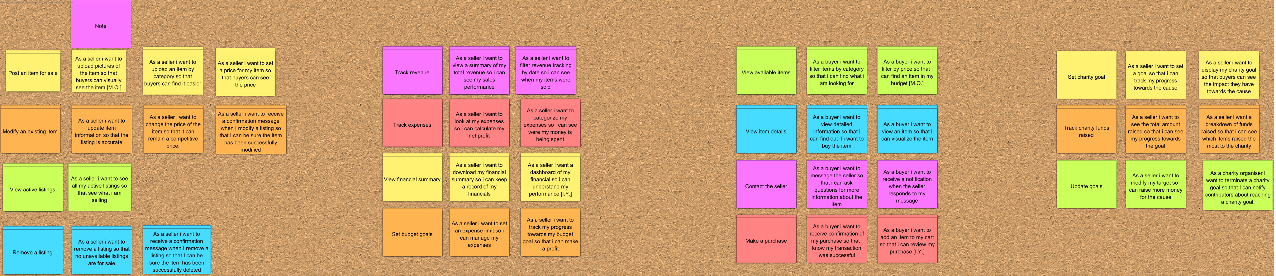

# Story Details

## Card

## Conversation

What **three** questions would you ask a product owner during an interview to further understand its details?

Pictures Questions (M.O.):

Why is uploading pictures important?

How will pictures be uploaded?

Is there a minimum standard for the photos uploaded?

Filter by price questions (M.O.):

What ranges are supported on the filter?

How should the filter be implemented?

Can there be multiple filters at the same time?

Finances Questions (I.Y.):

Do I need to have a goal in mind?

Am I able to change my financial goals?

What happens after I reach my goal(s)?

Cart Questions (I.Y.):

Am I able to remove an item from the cart if I change my mind?

Will I be able to navigate to the cart at any point while browsing the marketplace?

Do I need to have added an item to the cart to view it?

Three Questions for the Product Owner [1st card] (S.M.):

1. Can sellers change the price after posting the item?

2. Should there be any guidelines or limits on pricing?

3. Will the price automatically update if the item goes on sale?

Three Questions for the Product Owner [2nd card] (S.M.):

1. Should the breakdown show the total amount raised or individual contributions?

2. Can sellers filter the information by date or specific items?

3. How often should the fundraising data be updated?

## Confirmation Criteria

**Matas**

Given a seller is creating or editing a listing for an item they want to sell when the seller uploads one or more pictures of the item then the pictures are successfully saved, displayed in the listing and made visible to buyers when they view them.

Given a buyer is browsing the marketplace to find items that match their preferences when the buyer applies a price filter by setting a minimum and/or maximum price range then the system displays only the items within the specified range.

**Ice**

Given a seller wants to view their financial summary to understand their financial progression, when the seller navigates to the budgeting page of their profile then they are shown a summary of their current financial progression and can alter their goal when necessary.

Given a buyer wishes to add an item they want to buy but first review in the cart, when the buyer navigates to the cart page then they are shown the item(s) they added to cart and can review their purchase.

**Svitozar**

• GIVEN: A seller is logged into their account

• WHEN: They select "Post an item" button and select "Set a price"

• THEN: They can set a price that will be displayed to buyers

**Wireframe Diagram**

• GIVEN: A seller is logged into their account

• WHEN: They navigate to the fundraising dashboard

• THEN: They see a detailed breakdown of items sold and the contributions to charity

**Wireframe Diagram**

# Appendix

## Interview Questions

What are the challenges of selling items?

How is the process of fundraising now?

What features are you looking for?

How do you decide on which charity to donate to?

What is the result you are looking for?

Who is your target market?

What is the most important goal of this system?

## Interview Transcript

Staff Interview

*Q. How is the process of fundraising now?*

A. There is no way of collecting money in an easy and efficient way, thus they must use their own money, and they are pressured to feel guilty if they don’t contribute. Forced to sell items on Facebook marketplace, other staff

*Q. How do you decide on which charity to donate to?*

A. Based on local businesses in the community.

*Q. Do you personally choose the charity you donate to?*

A. The Staff have a vote on which charity they donate to.

*Q. Would you like a feature to display fundraising goals or progress?*

A. Yes. they would like how much has been raised so far and how far from the goal they are.

*Q. Would you like to include people in the progress?*

A. They can choose to be anonymous.

*Q. What payment methods would you prefer to use?*

A. Cash from other staff or online through Revolut.

*Q. Do you need any special features for tracking or managing sales?*

A. No, if it is in the community they can personally give it to them or place the items somewhere to collect.

Student Interview

*Q. What challenges do you face when selling items?*

A. Finding people to sell to, difficult to find out what people want, communication with people who own the item.

*Q. How do you currently sell items?*

A. Post on social media, tell people in person/tell them to tell others.

*Q. And is that effective?*

A. Word of mouth is okay, social media is better, wider range.

*Q. Would you use the platform more if it were integrated with social media?*

A. Yes.

*Q. What difference does that make?*

A. Purpose to go on app, more convenient instead of posting social media.

*Q. Who do you sell to already?*

A. Other students, staff, within MTU.

*Q. How often would you sell your belongings?*

A. Based on when money is needed… weekly or monthly.

*Q. What payment methods would you prefer to use?*

A. In person cash/Revolut online.

*Q. What features are you looking for?*

A. Ability to search throughout the marketplace (categorise items, range of price).

*Q. What is the result you are looking for?*

A. To reach a broader range of people to make selling items easier.

## Trello Board Screenshots

Trello link: <https://trello.com/invite/b/67321869be51cb682c2d2936/ATTIf661fca8048369d18bc8163e78c25432C07A6CA8/project-tasks>

## Background Research

For background research we looked at what options students and staff have currently. This was done by going through existing systems they currently use.

For example, we looked at the marketplace on Facebook and eBay and looked at the possible problems that MTU staff and students had when using these websites.

This allowed us to gather the problems we had to solve in our system.

# Bibliography

Inspiration for MTU Marketplace UX and UI design for JustInMind prototype

<https://www.mtu.ie/>

User Flow Diagram Examples

<https://www.justinmind.com/blog/user-flow/#12-exceptional-user-flow-examples>

Etsy

<https://www.etsy.com/>

Facebook marketplace

<https://www.facebook.com/marketplace/>

eBay

<https://www.ebay.ie/>

MTU Website

https://www.mtu.ie/

Requirement Engineering Lecture Slides

# Project Retrospective

Ice Ybanez

**What could have been done to make your project better (if given more time)?**

Research through interviewing various persons for information about what could be done for the project would make it better. More insight to how the current system works, and its problems would be useful as a guide to accomplish a better product.

**Who did what in the project and how well?**

We delegated tasks to one another to complete the weekly deliverables.

Matas did a lot of work with the grids on Visual Paradigm and Brainstormed a lot, then executed what was to be done.

He did well with accomplishing tasks ahead of time and kickstarted majority of the tasks for me and Svitozar to complete our tasks.

Svitozar helped with adding more information to what was already laid out and having his own ideas to add to the tasks that needed to be done.

He did well with the use case diagram and his drive to see tasks through aided in completing deliverables.

**What factors can help bring more active participation of each member?**

Knowing one another a little more could have aided in our openness to actively participate in conversations and brainstorming with the tasks.

Matas Orliukas

**What could have been done to make your project better (if given more time)?**

Had we been given more time we could have interviewed more thoroughly and developed the prototype more.

**Who did what in the project and how well?**

Everything was done as a group, but Ice improved on the JustInMind prototype a lot and Svitozar developed the Use Case diagram.

**What factors can help bring more active participation of each member?**

Team meetings would help bring more active participation from each of the team members and clear communication, so everybody is aware of what needed to be done.

Svitozar Menshchykov

**What could have been done to make your project better (if given more time)?**

• More User Testing: Test with more MTU students and staff to gather feedback and further improve the user experience.

• Add More Features: Include a chat-bot assistant to help users, better filtering options to easily find items, and a rating system for buyers and sellers.

• Improve Design: Make sure the user interface works well on mobile devices.

**Who did what in the project and how well?**

Each team member contributed to every part of the weekly deliverables. However, everyone also focused more on specific sections:

• Svitozar: Use Case Diagram, Wireframes, and Grids

• Matas: Non-Functional Requirements, Business Rules, and Use Case Stories

• Ice: Documentation, JustInMind prototype and User Flow Diagrams

Everyone collaborated well, completing their tasks and supporting each other throughout the project.

**What factors can help bring more active participation of each member?**

• Clear Roles: Make sure everyone knows their tasks and what is expected of them.

• Regular Meetings: Have meetings to check progress, solve problems, and stay on track.

• Motivation: Recognise everyone's hard work to keep them motivated and engaged